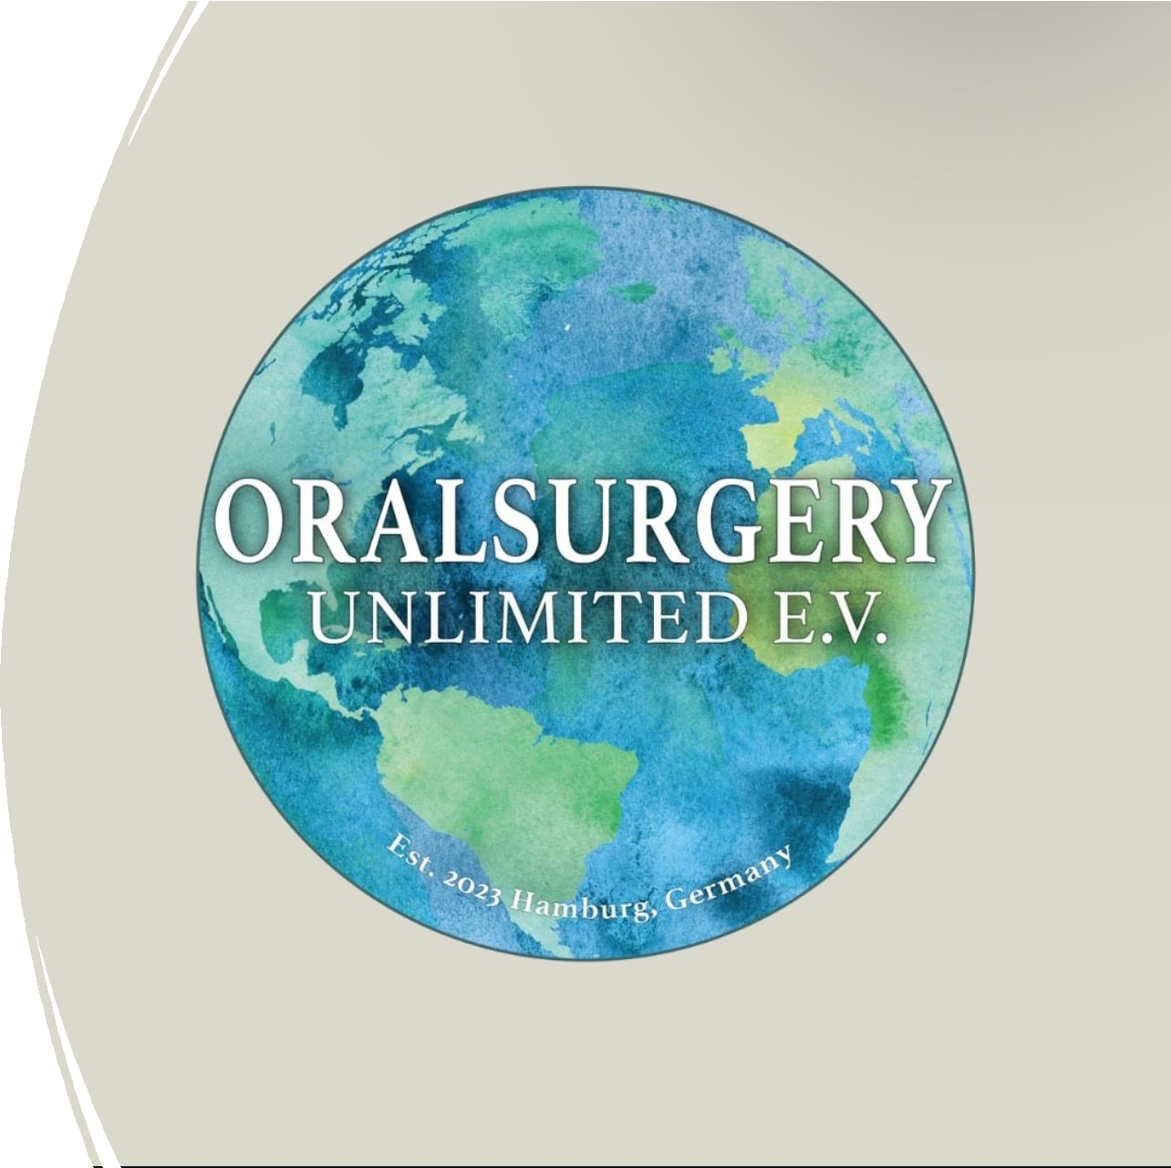

Project Gambia 2025

Dr. Idris Najafi
Dr. Mahdi AL-Zalimi
Muntazar Al-Zalimi 6th year student Faraz Ahadi 6th year student


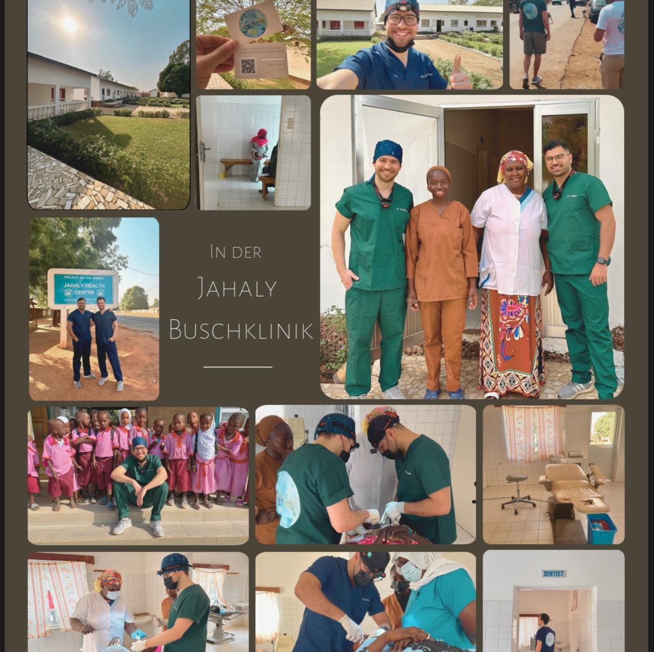
Oral Surgery Unlimited e.V
Founded in 2023 Hamburg Germany Co- founder and Chairman Dr Idris Najafi
‘’Plovdiv Graduate 2020’’
We are a group of surgeons based in Hamburg and founders of OralSurgery Unlimited e.V., a non-profit organization established in 2023. Our mission is rooted in a deep sense of gratitude for the education and opportunities we have received, and a commitment to give back through our medical expertise. We focus on delivering essential surgical and dental care to underserved regions where medical help is scarce and urgently needed. Our organization is entirely non-profit and operates solely through charitable donations. These contributions are used to purchase essential supplies such as gloves, masks, anesthesia, and other medical necessities that make our work possible.

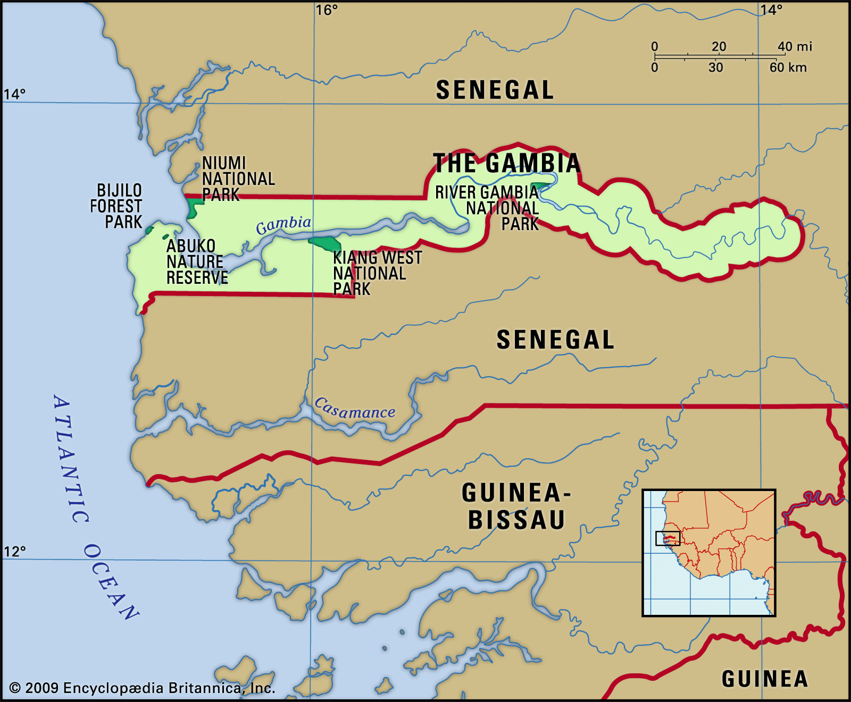

Gambia ‘’Smiling Coast Of Africa’’.
Neighboring country to Senegal and Mali.


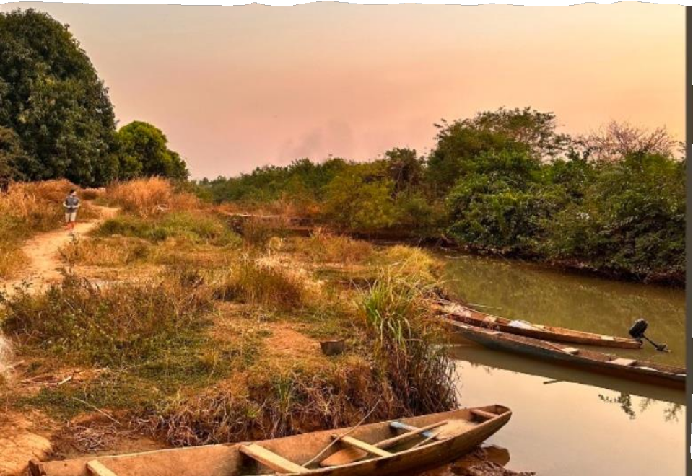
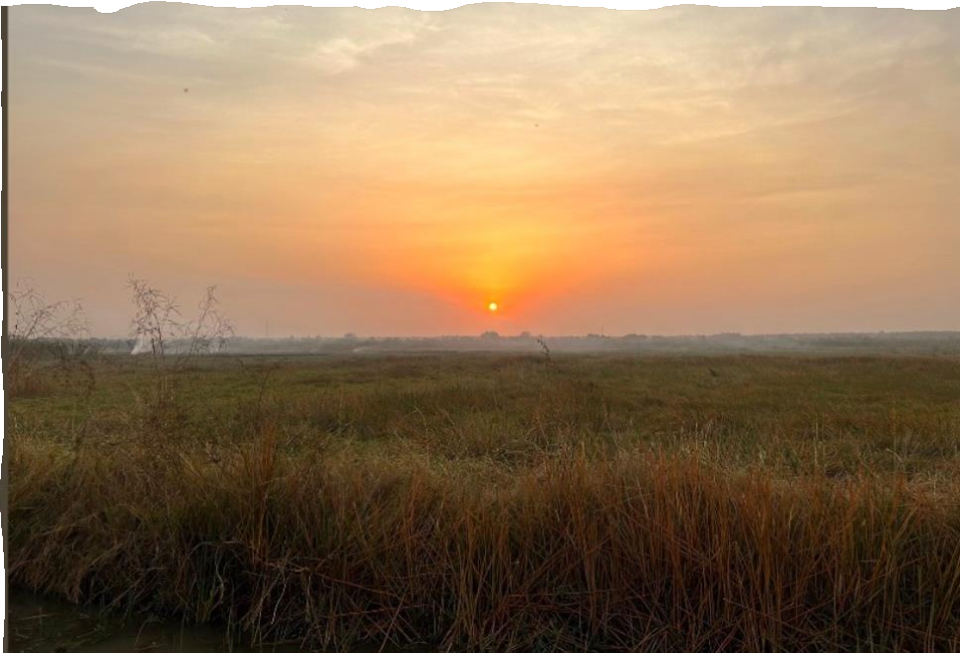
Nature
- The natural environment in The Gambia provides a rich source of traditional remedies and healing plants, offering valuable support for local health and wellbeing.

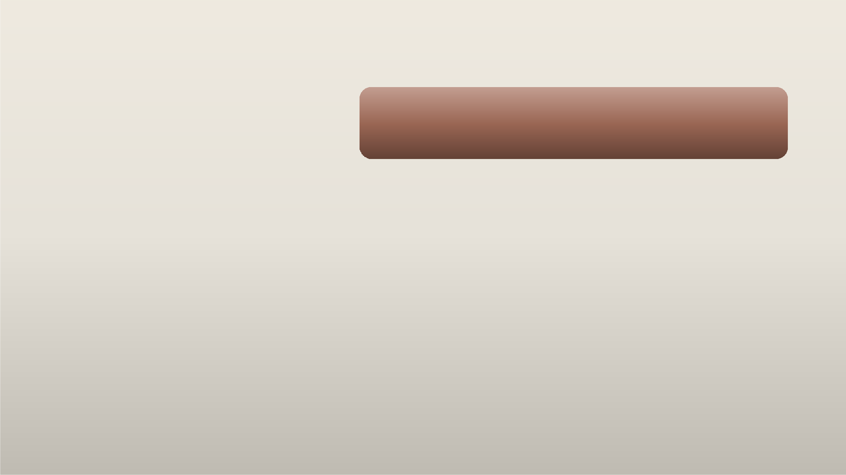

Healthcare in The Gambia
Outside the capital city, healthcare services
in The Gambia are limited.
Limited Infrastructure: Rural areas primarily rely on basic health posts and minor clinics, which often lack essential medicines and equipment.
Staffing Challenges: Many facilities operate without doctors or specialized healthcare workers, leading to gaps in service delivery.
Access Barriers: Patients frequently travel long distances to reach healthcare centers, only to encounter limited resources upon arrival.
Dependence on Traditional Medicine: Due to these challenges, traditional medicine remains a primary healthcare source in many rural communities.

Primary care in villages of population. >400)

Secondary care via large/small health centres

Tertiary care through 4 main referral hospitals.

There are 8 main health centres, 16 smaller ones, 200+ mobile clinic teams, and widespread facility access (over 80% of the population). However, staffing remains critically low.

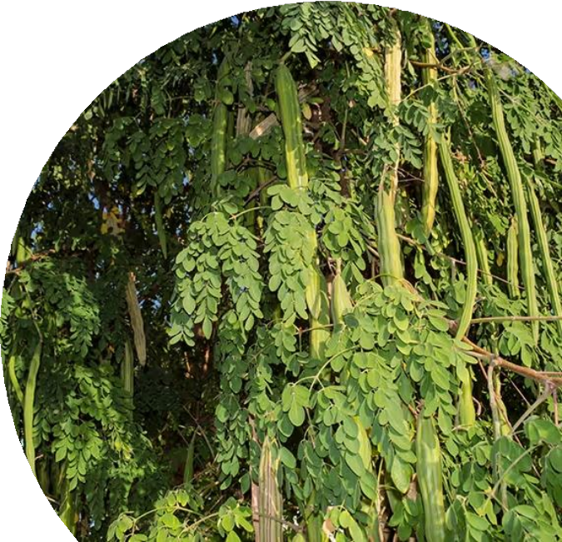
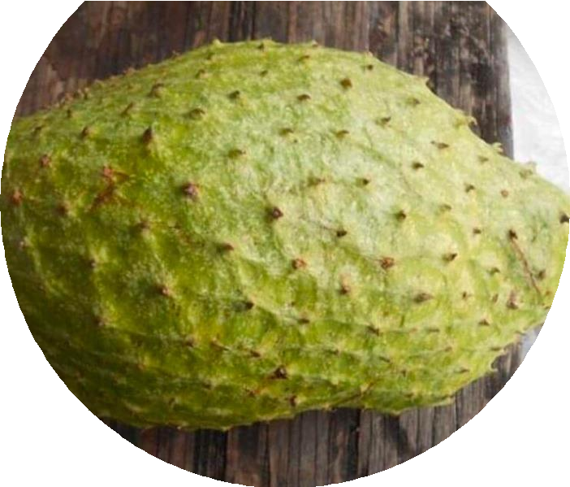
Traditional remedies

Solom solom and soursop are fruits often eaten to
lower blood pressure and boost the immune system.
Moringa is a powerful plant found all over the country.
Its leaves are high in iron, and people believe moringa soup helps treat malaria, especially common during the rainy season.
Dengidek (Wolof), Barkele (Pular), and Owo (Mandinka) are names for a traditional plant used to treat many illnesses like stomach problems, cough, fever, colds, toothache, snake bites, and even sickle cell anemia.

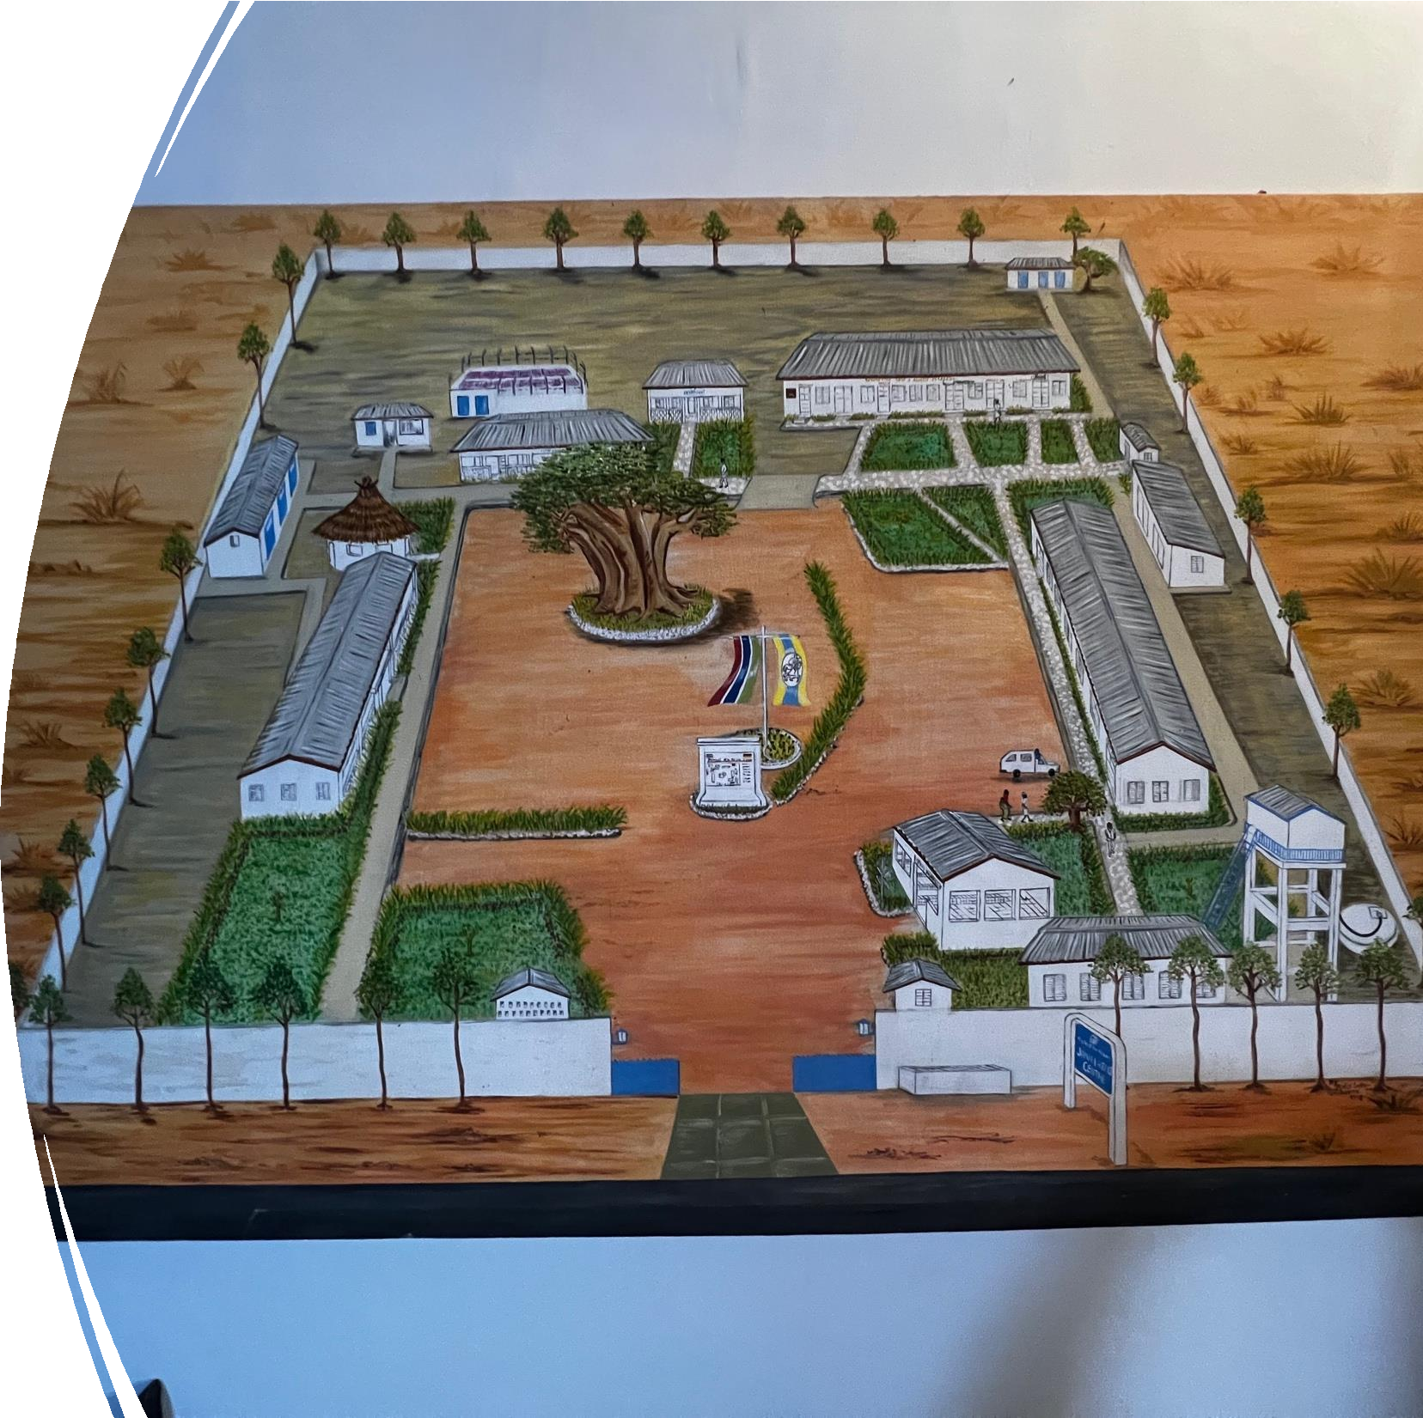
Jahaly Health Center

- The clinic is located in the village of Jahaly, approximately 300 kilometers from the capital city. It is the sole healthcare facility available to residents in the area. Due to the absence of a dentist within a 300- kilometer radius, access to dental care is extremely limited, making it difficult for the local population to receive necessary treatment.

Waiting Room
Patients have been informed prior through radios, papers and mosques etc.

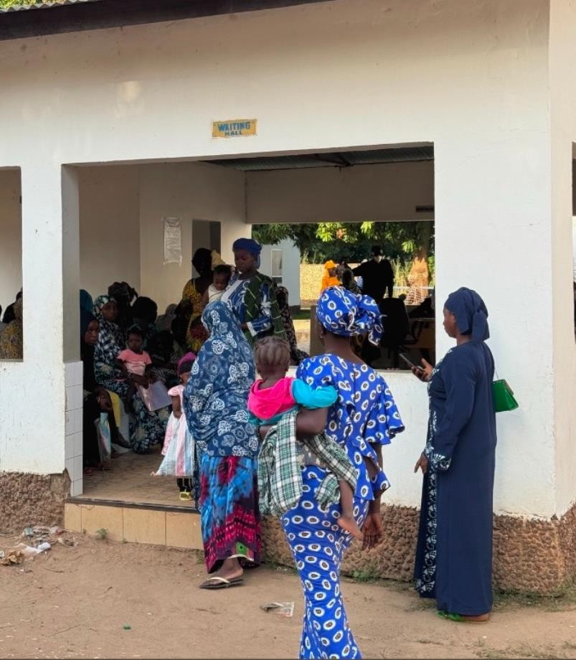


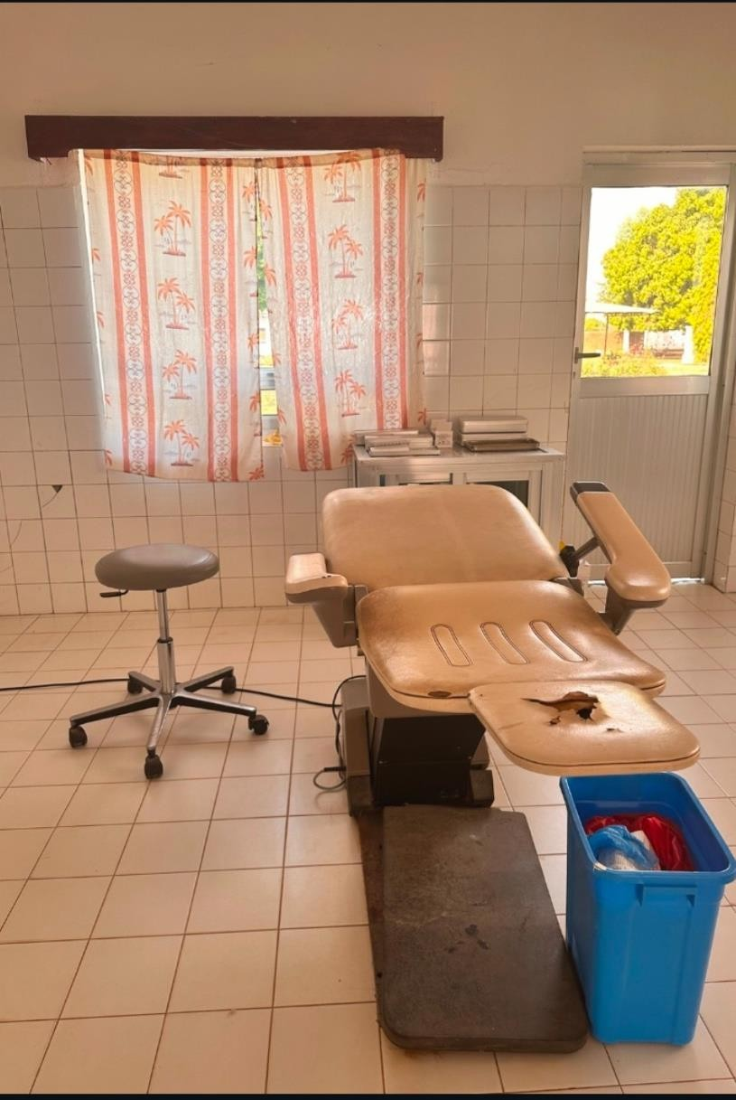
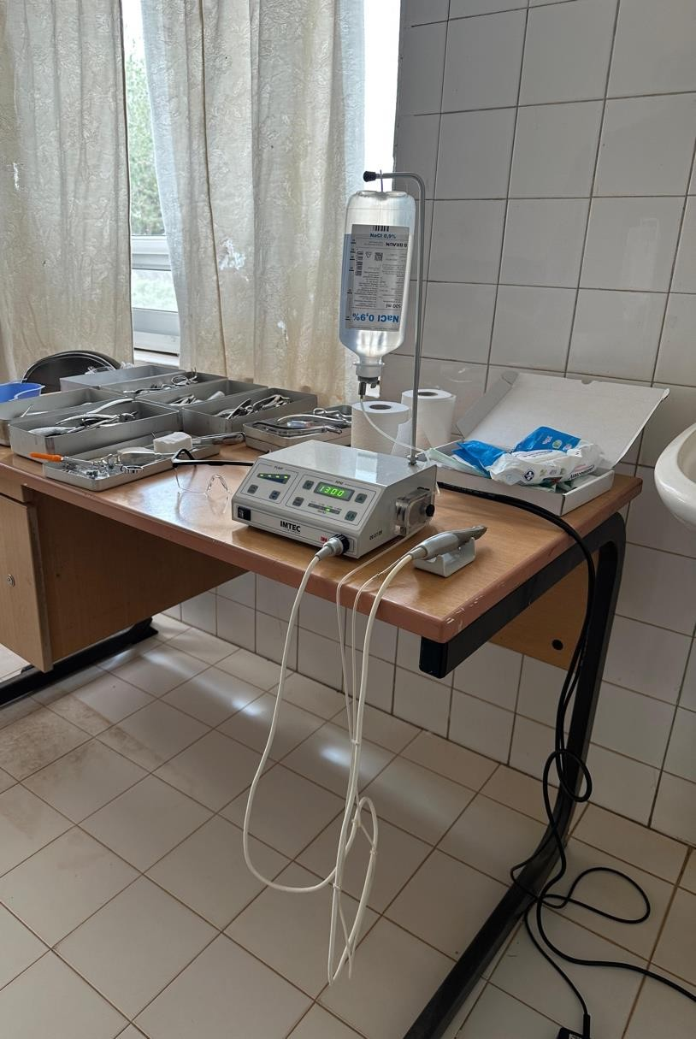
Dental Clinic
A new surgical motor thanks to donations


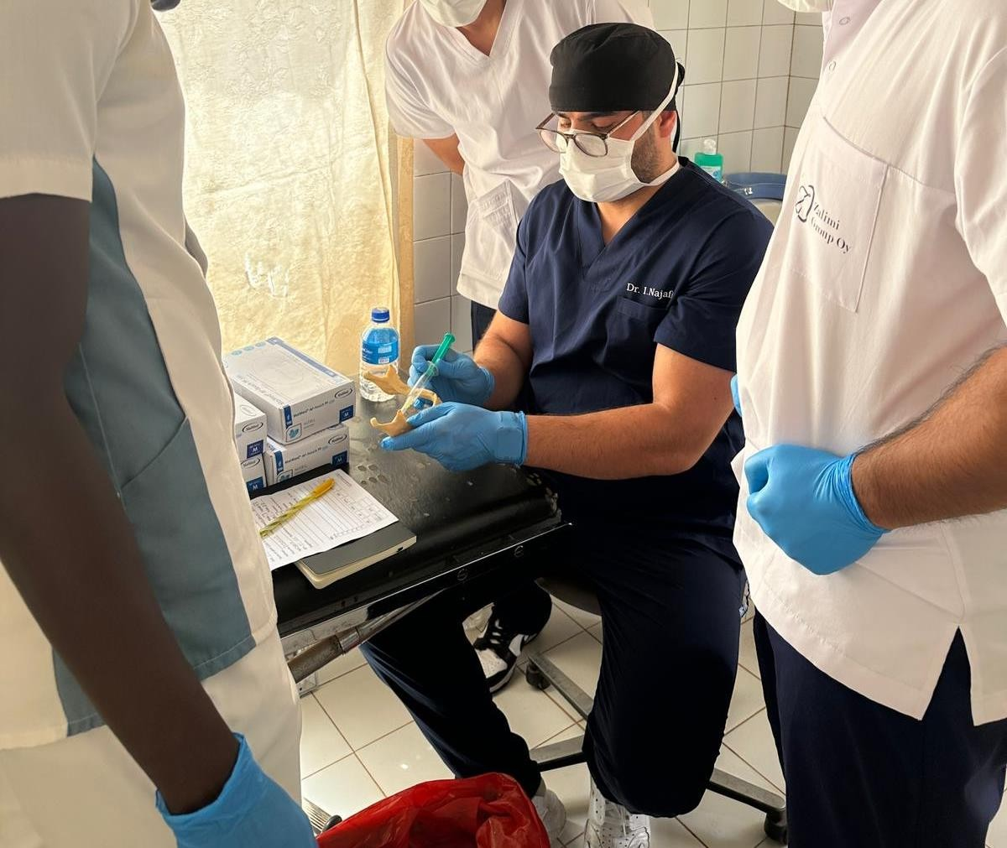

Preparation to begin the day

Refreshing nerve block techniques

First Patient of the day

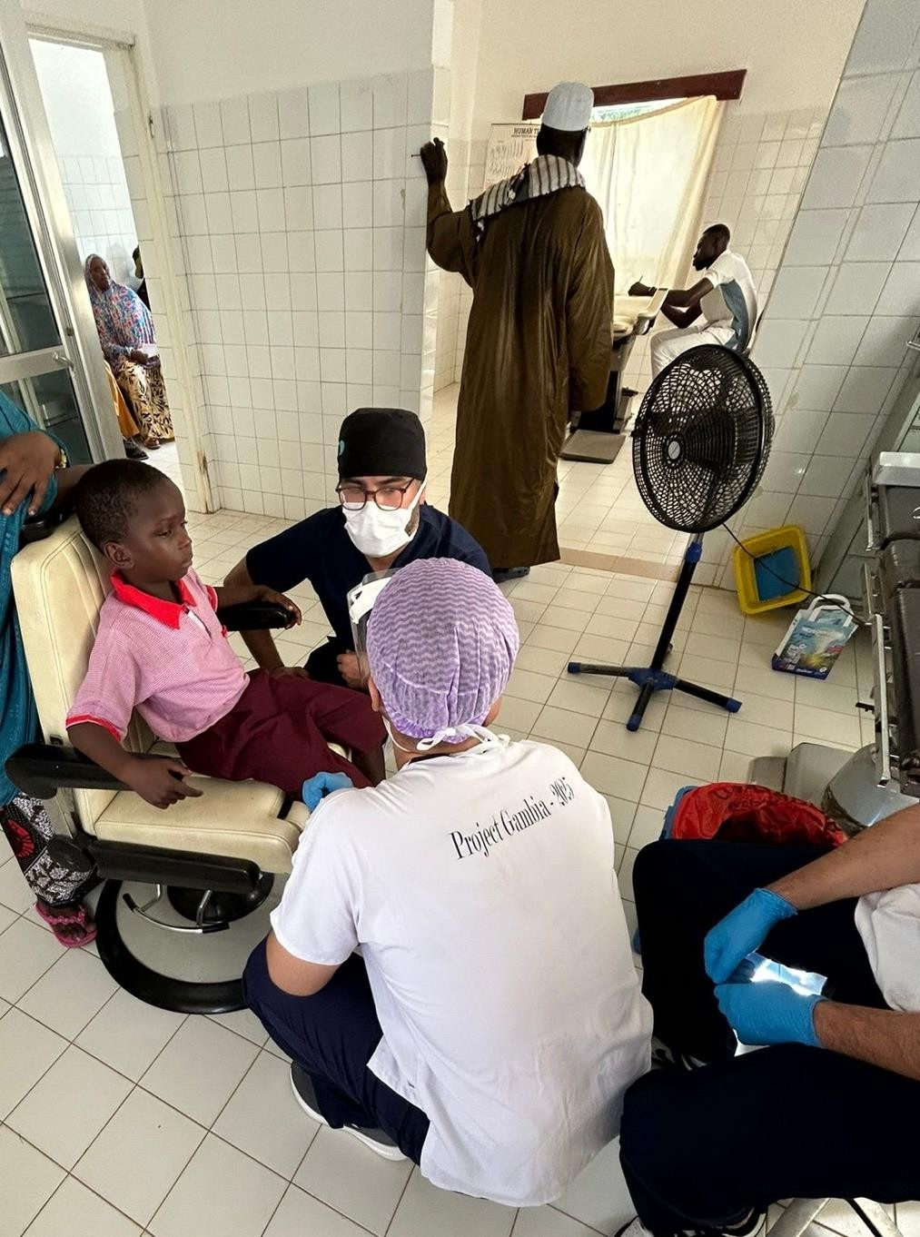

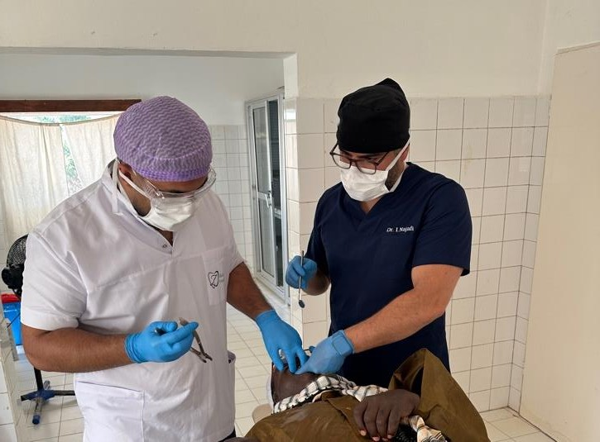
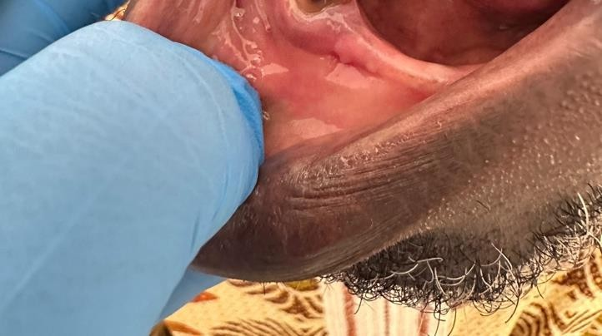
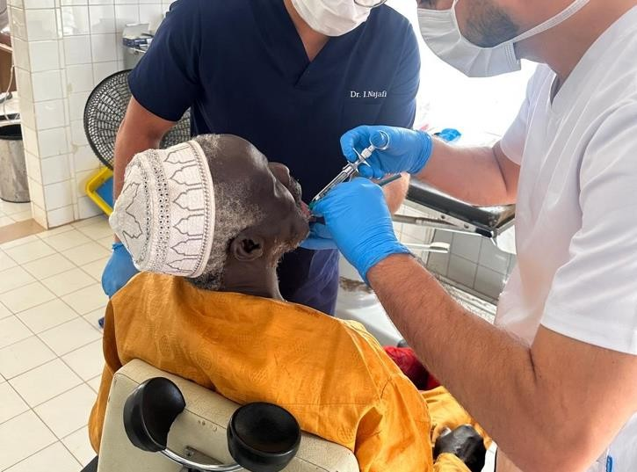
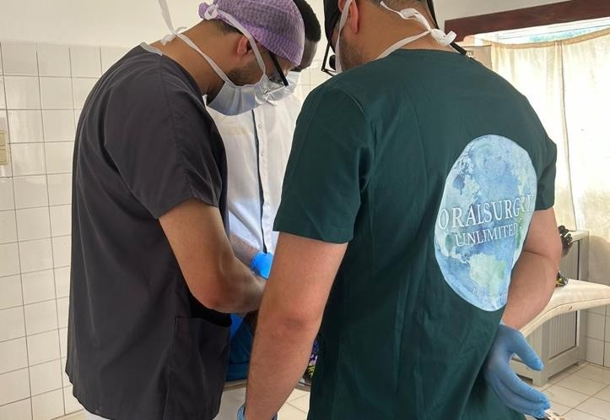
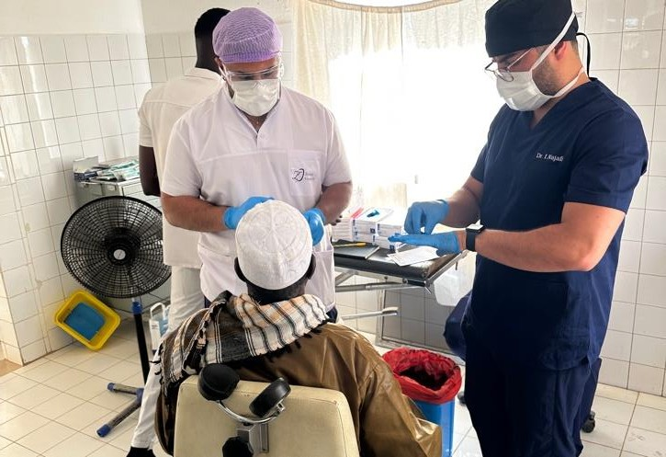
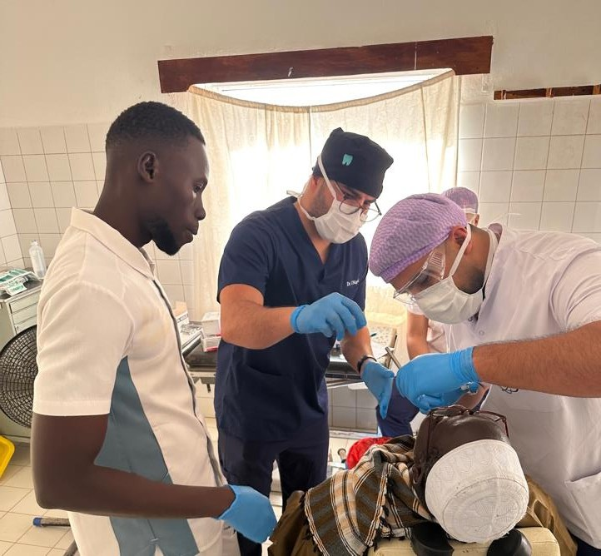
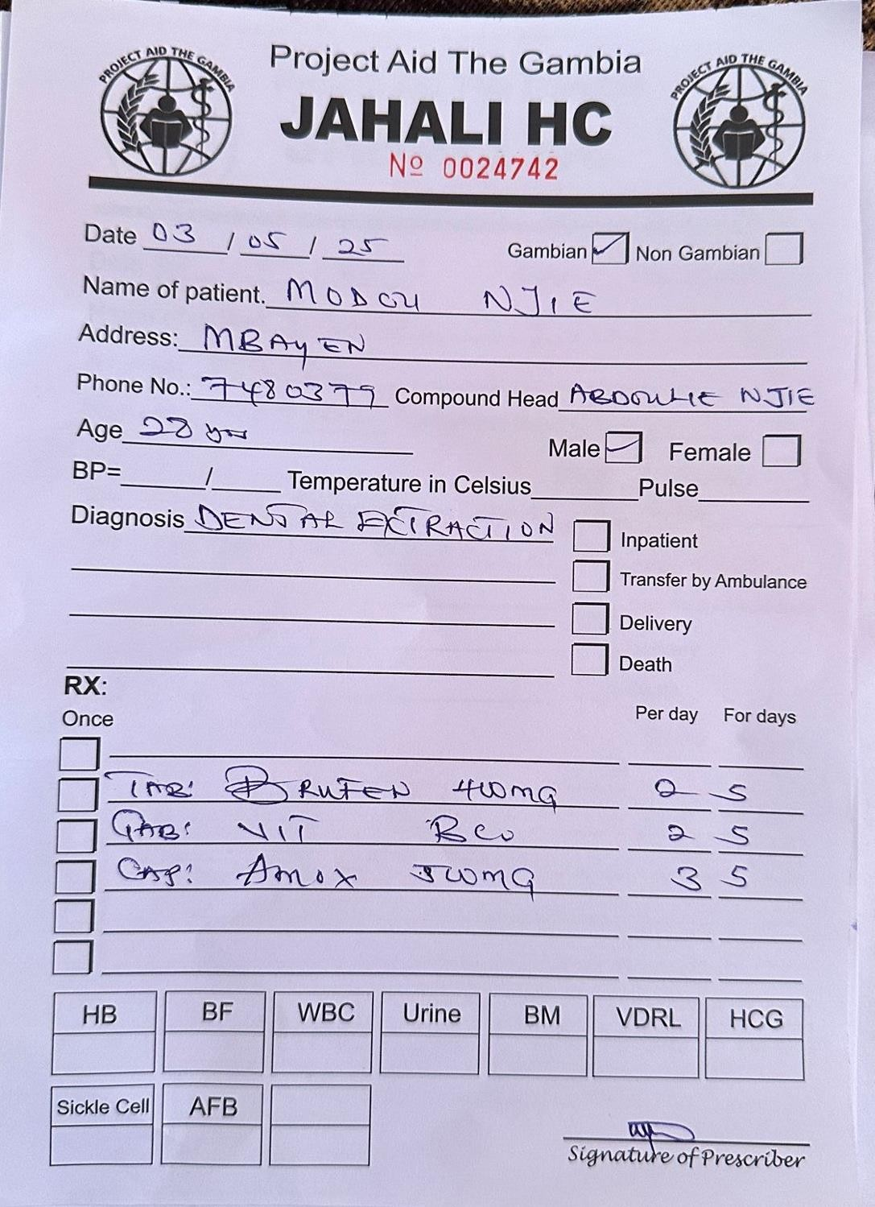

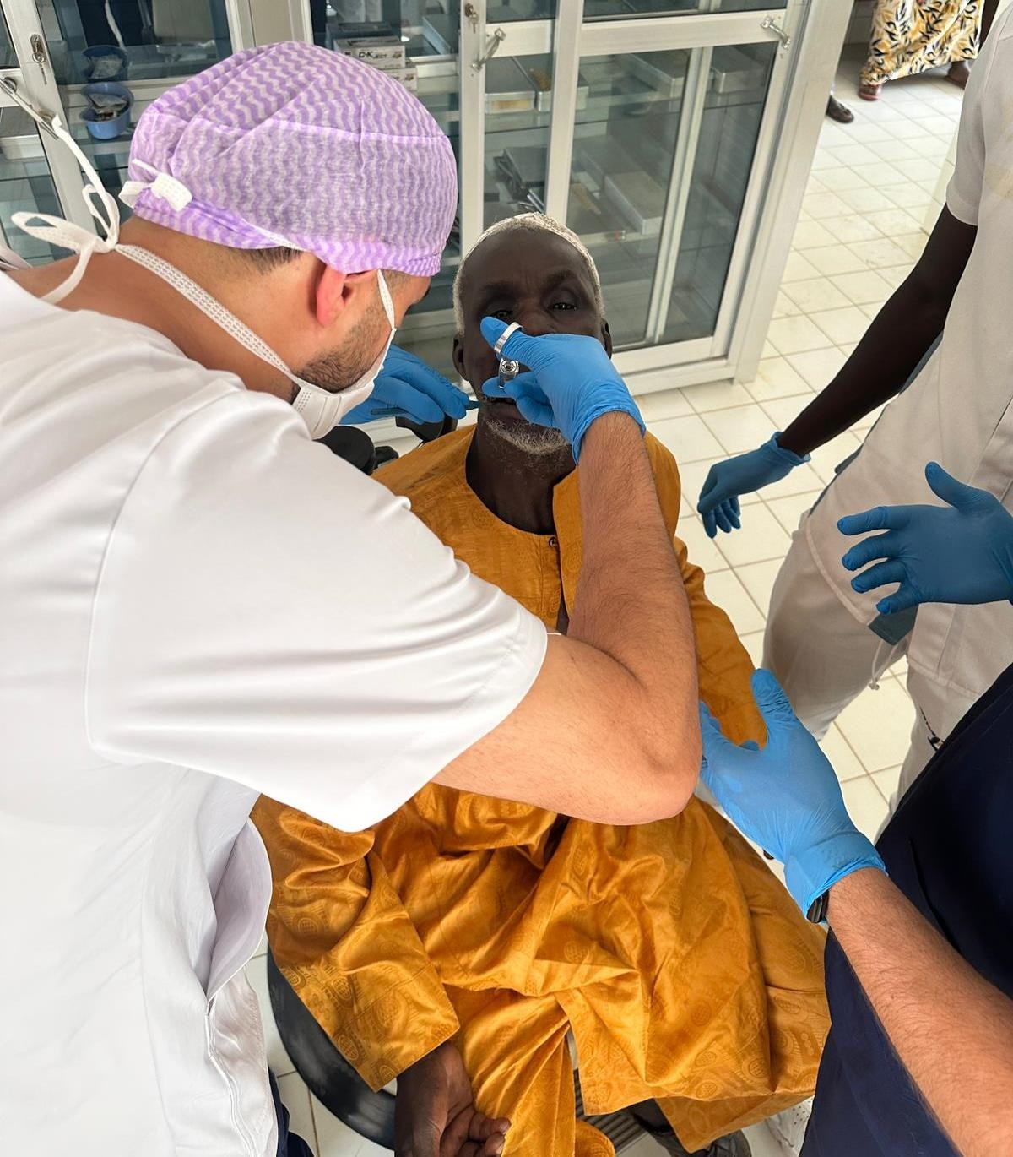

Different anesthesia techniques were used to reach optimal anesthesia, but each procedure was strictly under supervision

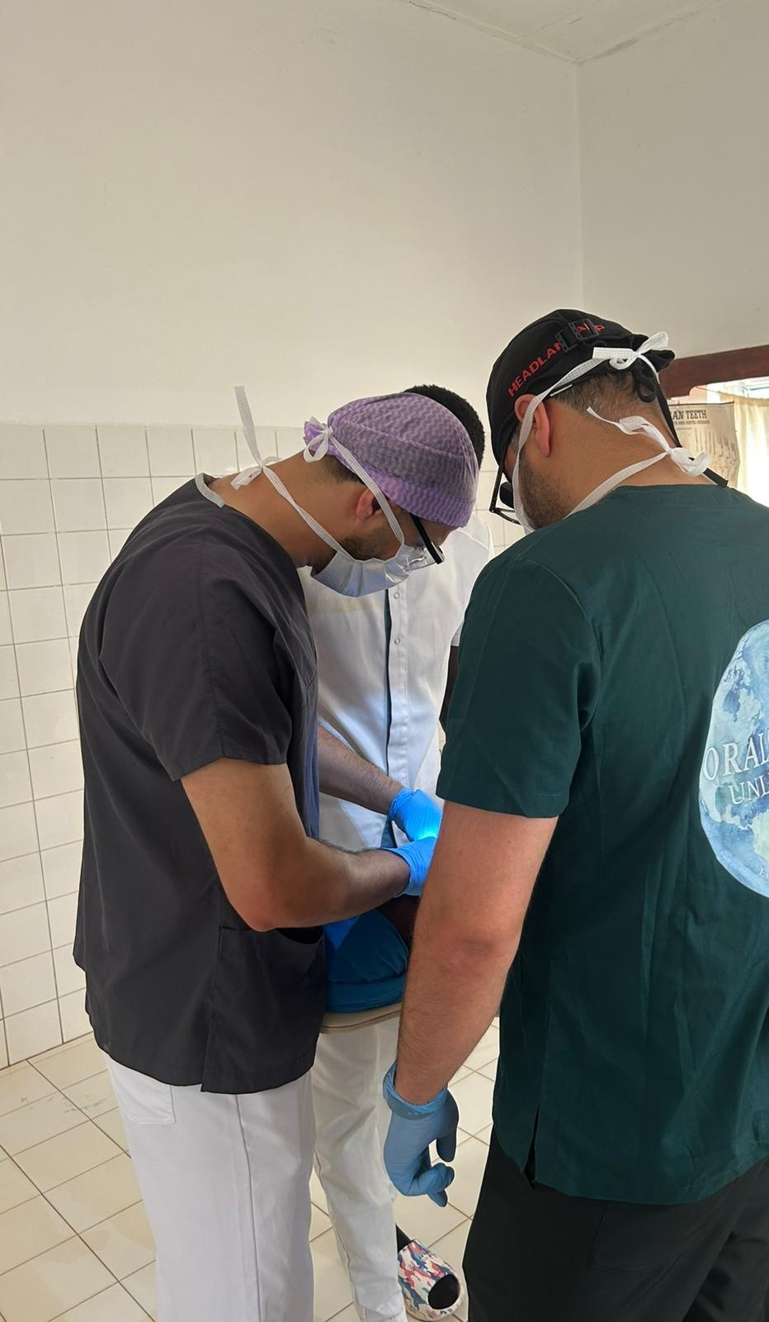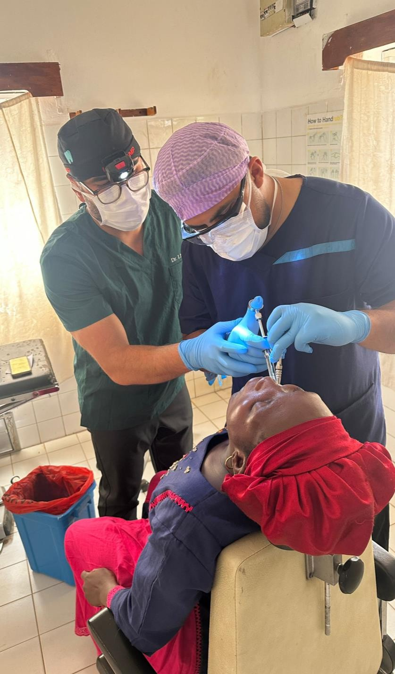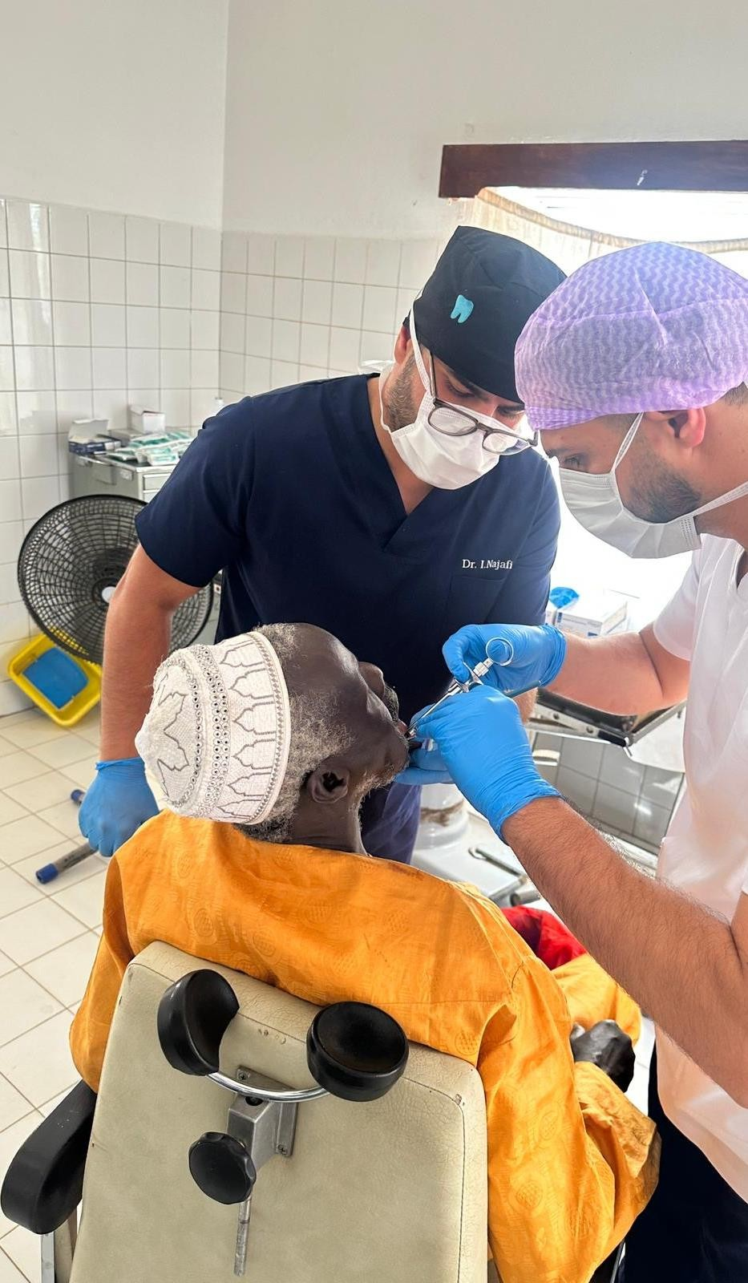

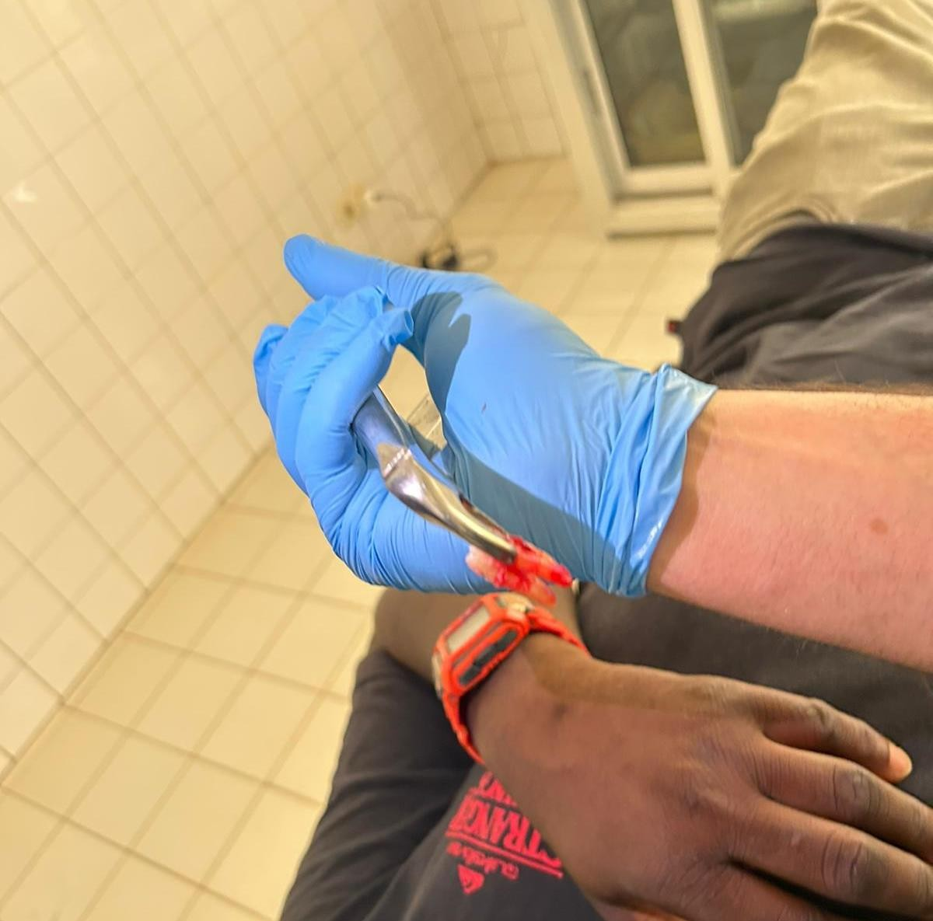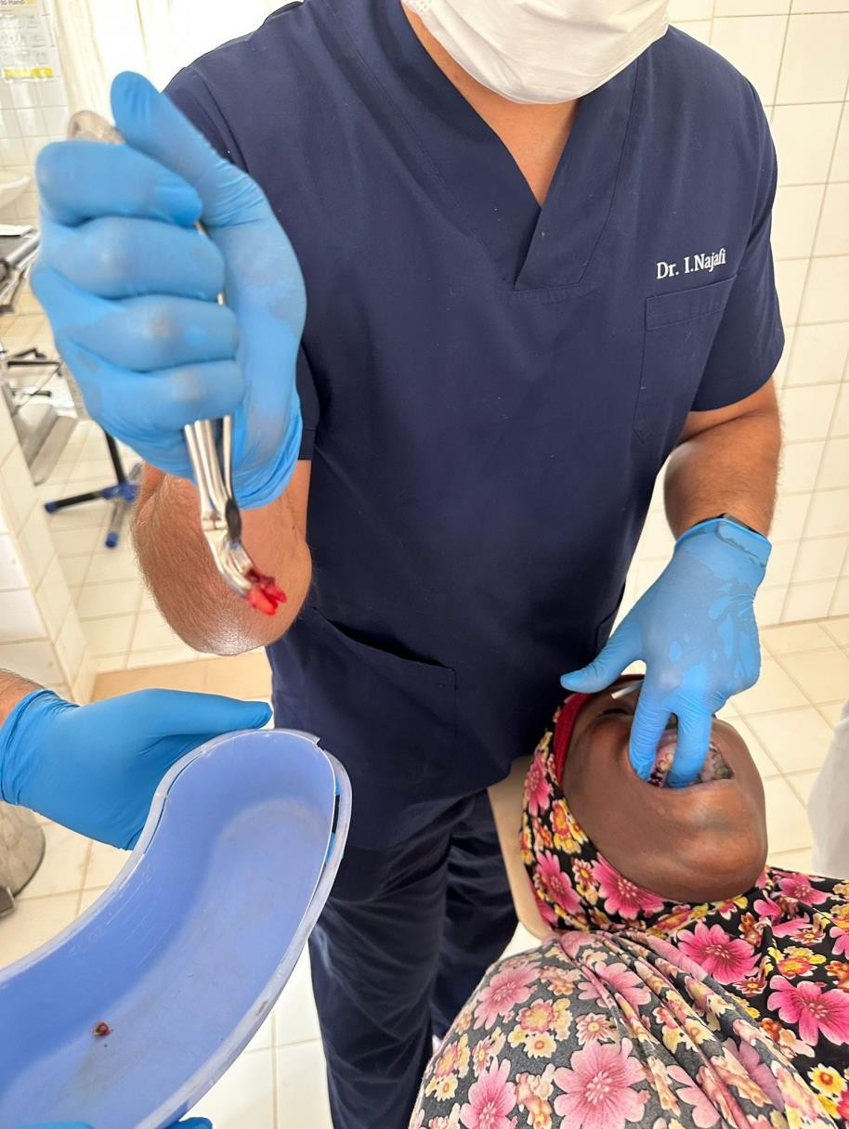


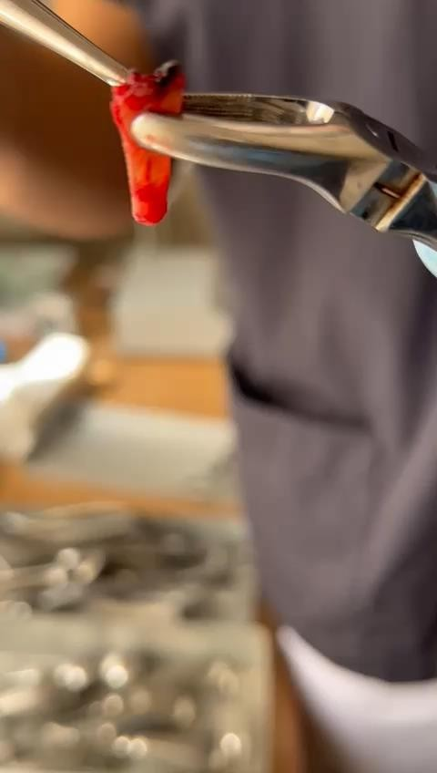
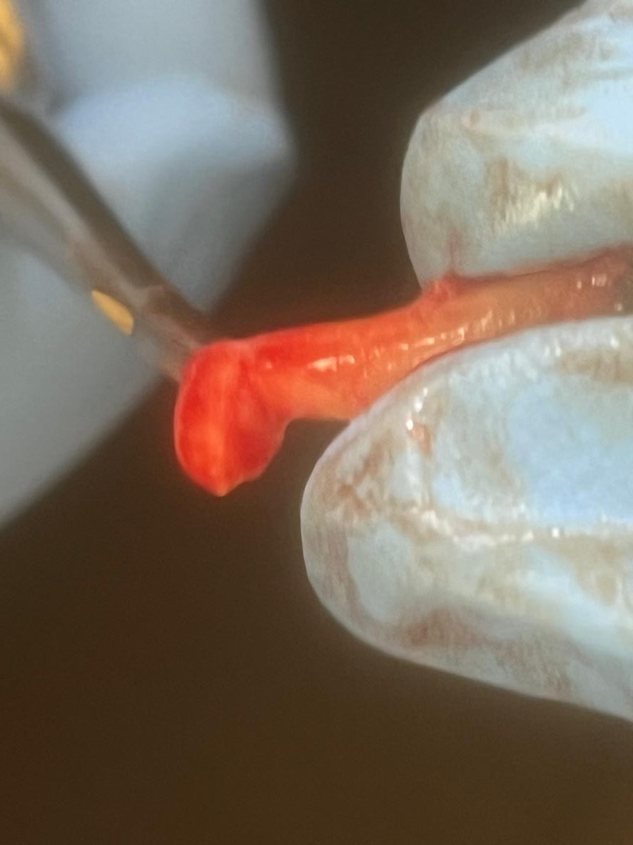

Periapical lesion

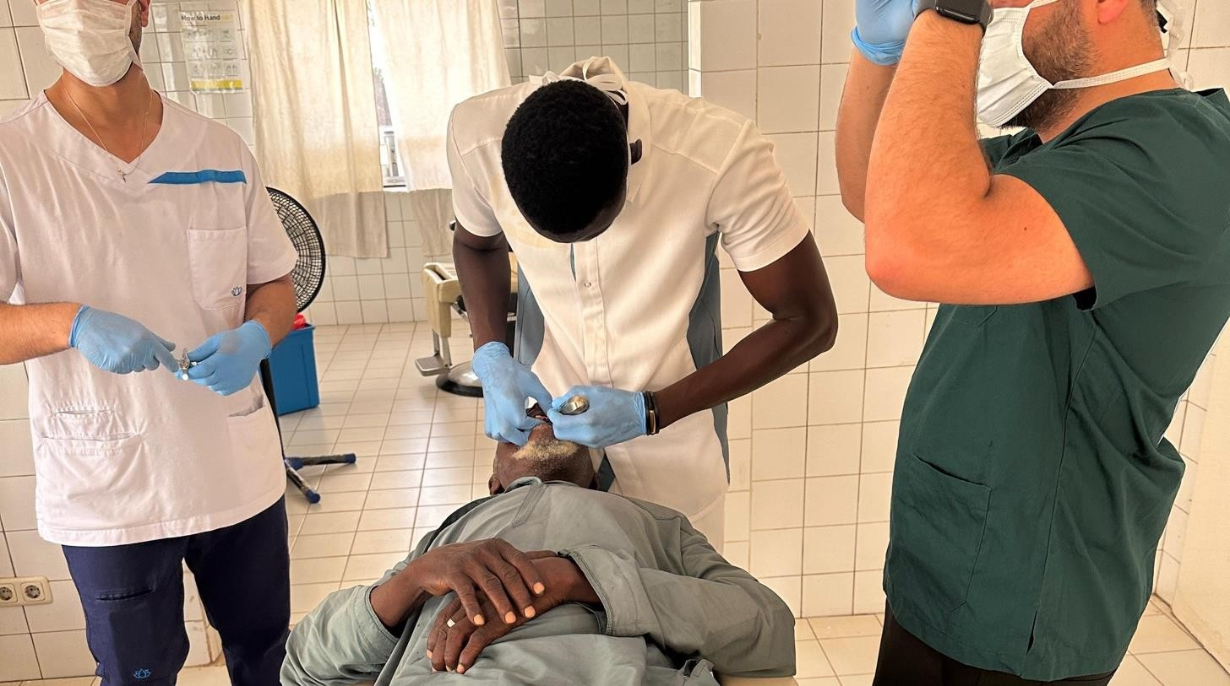
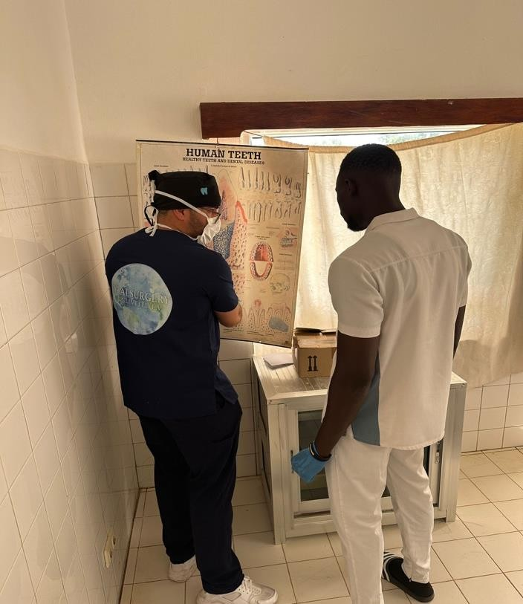
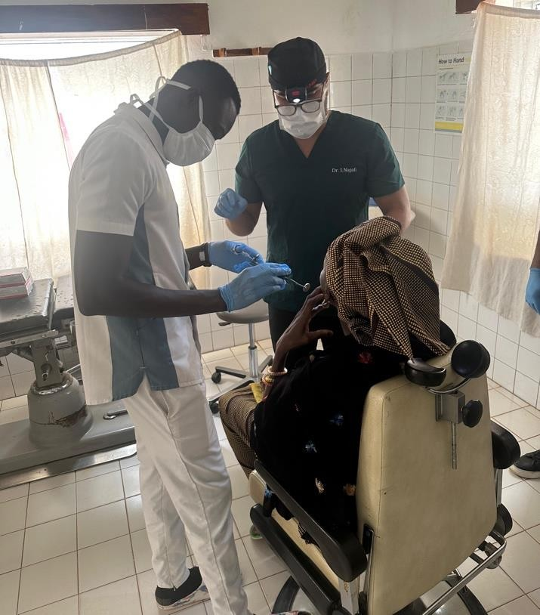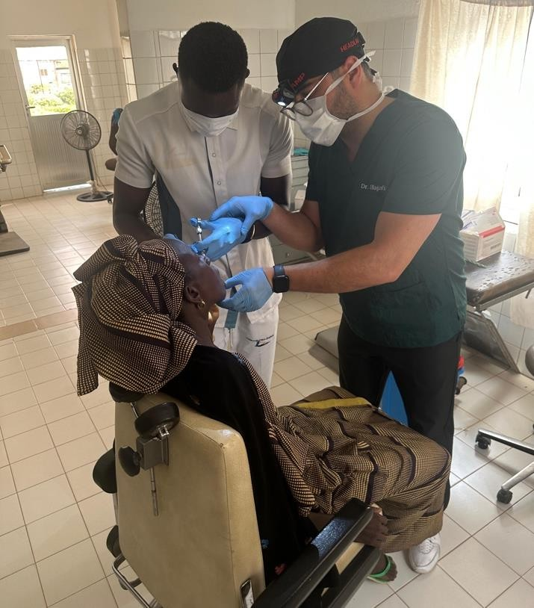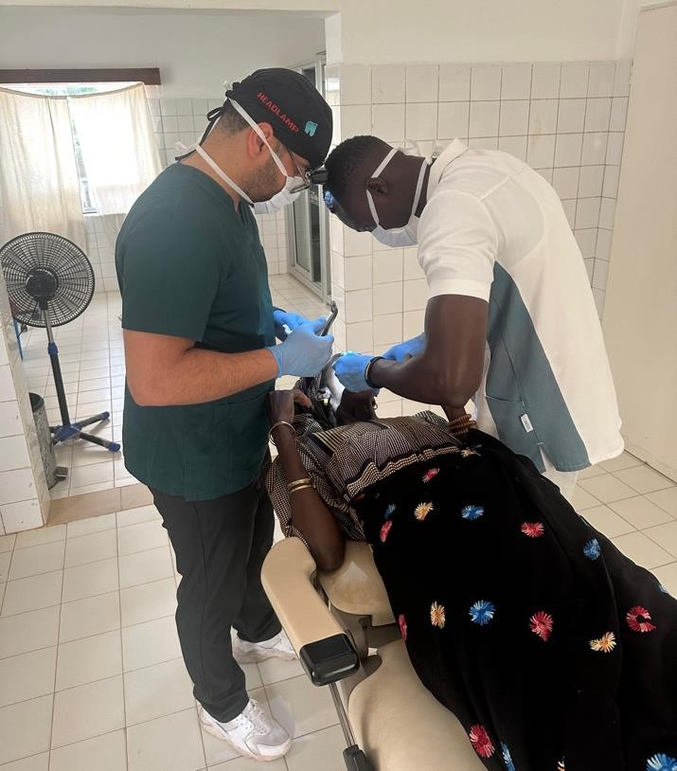

Teaching/mentoring local nurses and health workers In basic surgery
- Its important to spread knowledge to the locals.



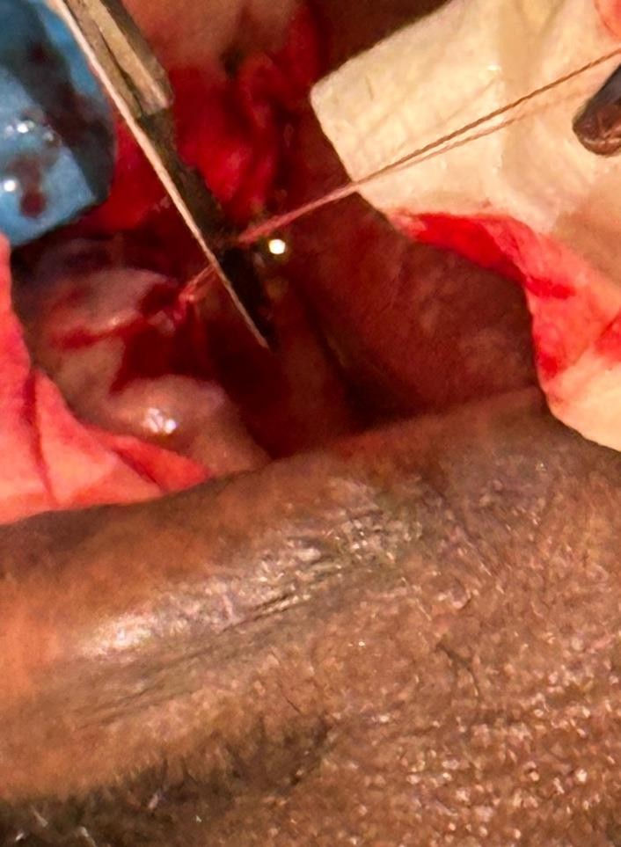
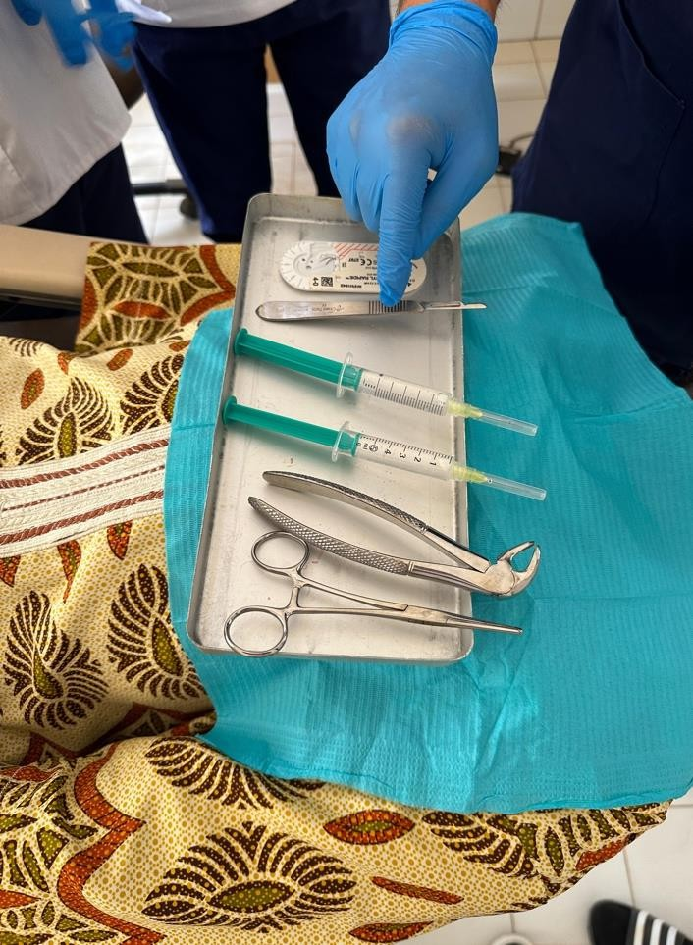
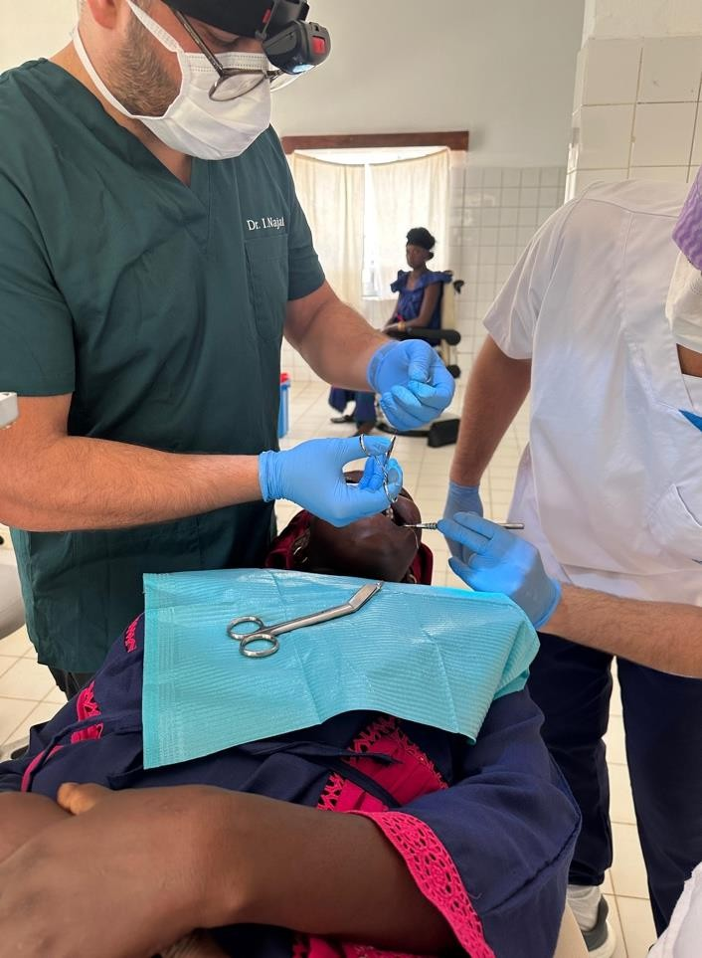
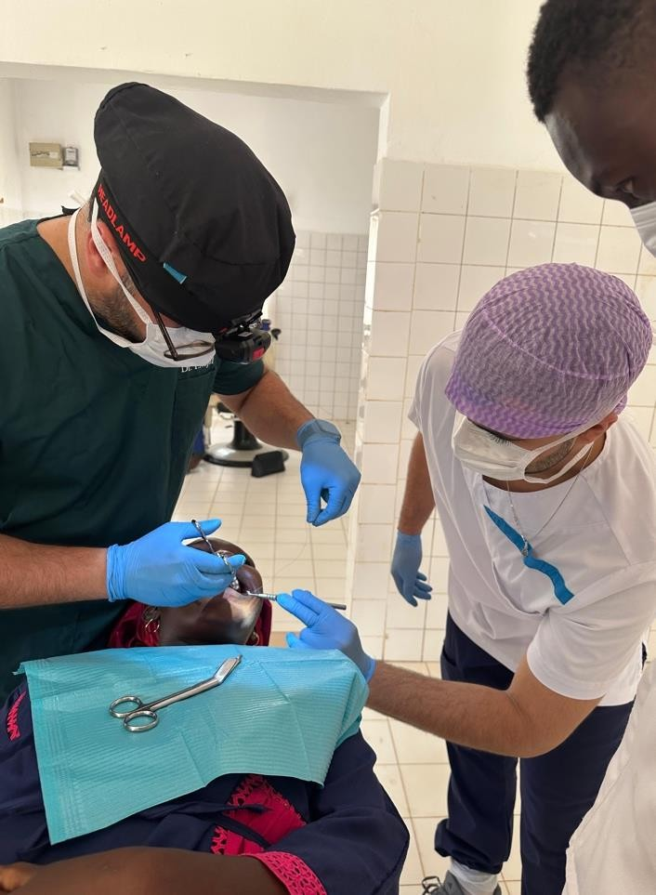
Abscess treatment
- Some cases required suturing for better healing.



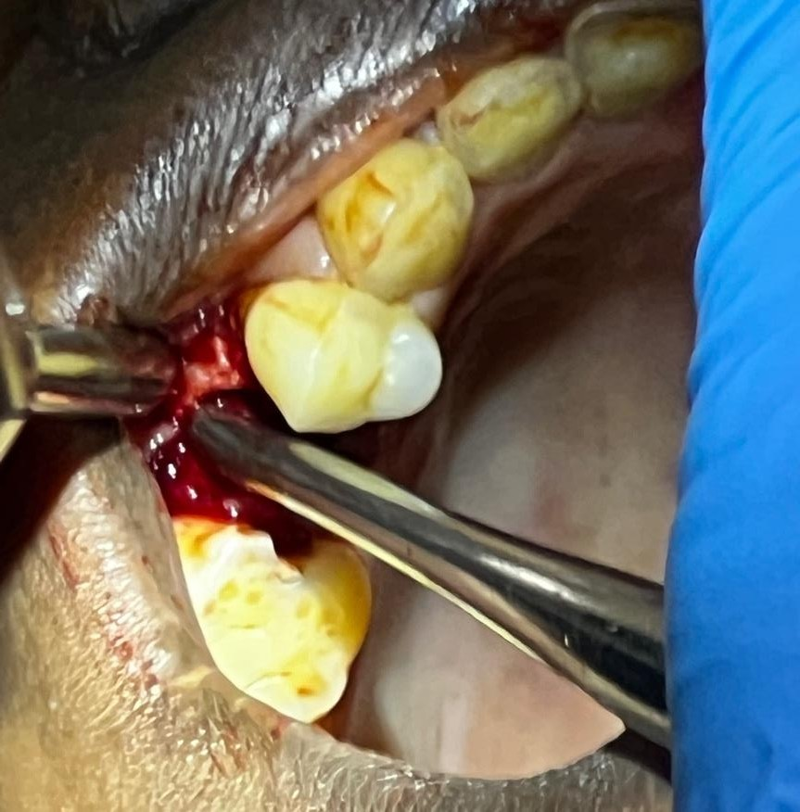
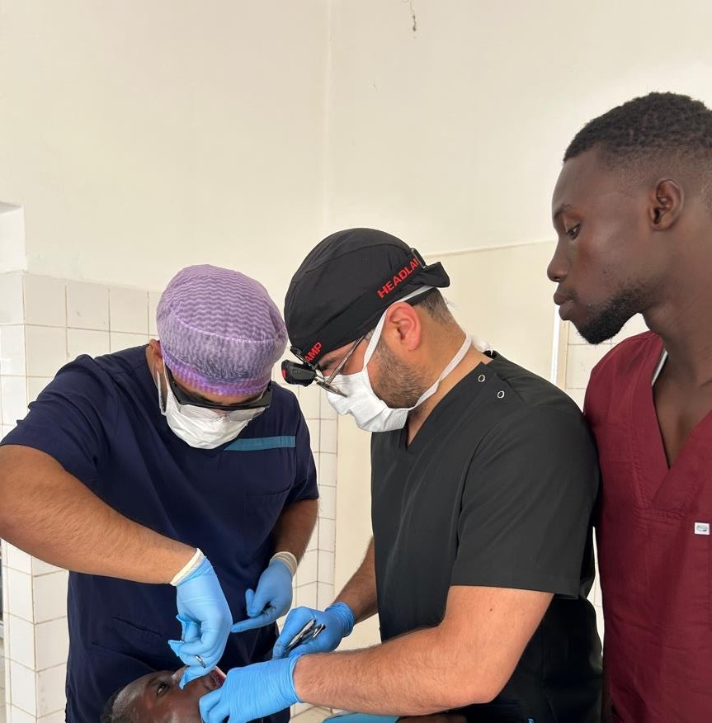
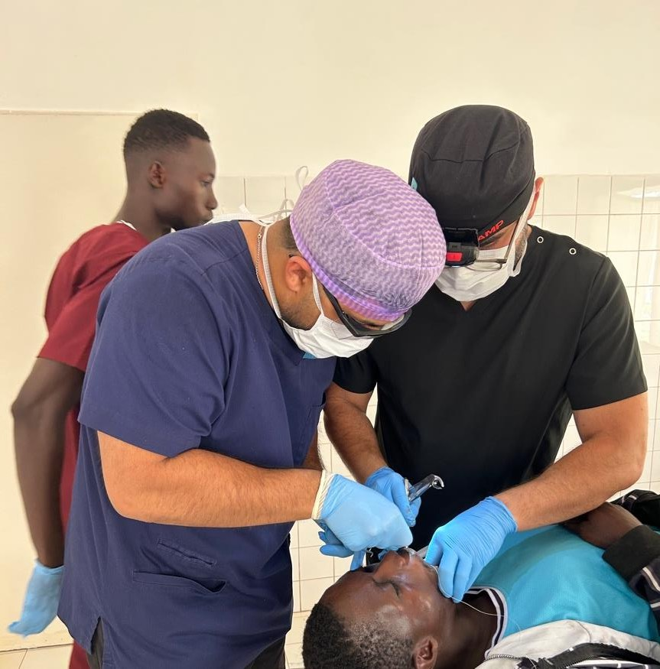

Flap and suturing

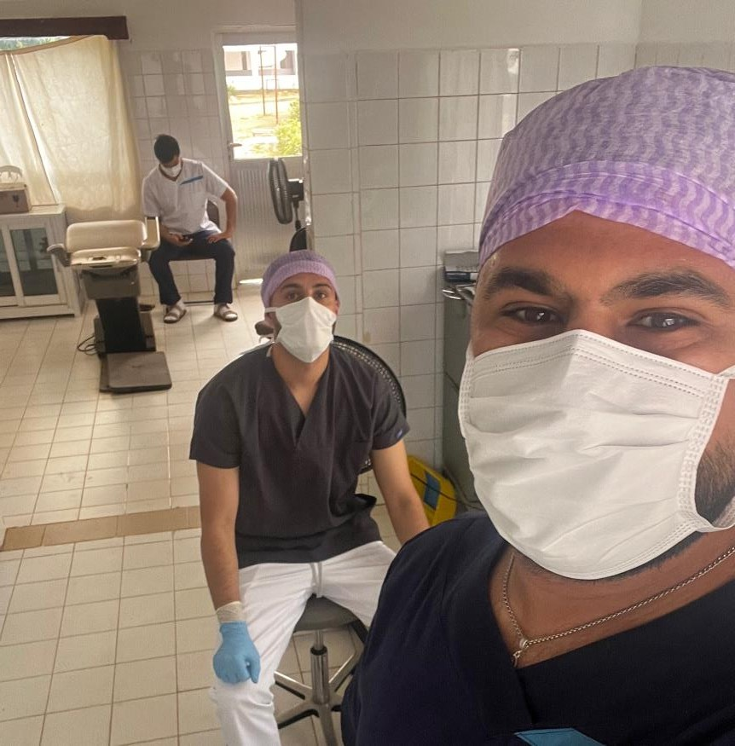
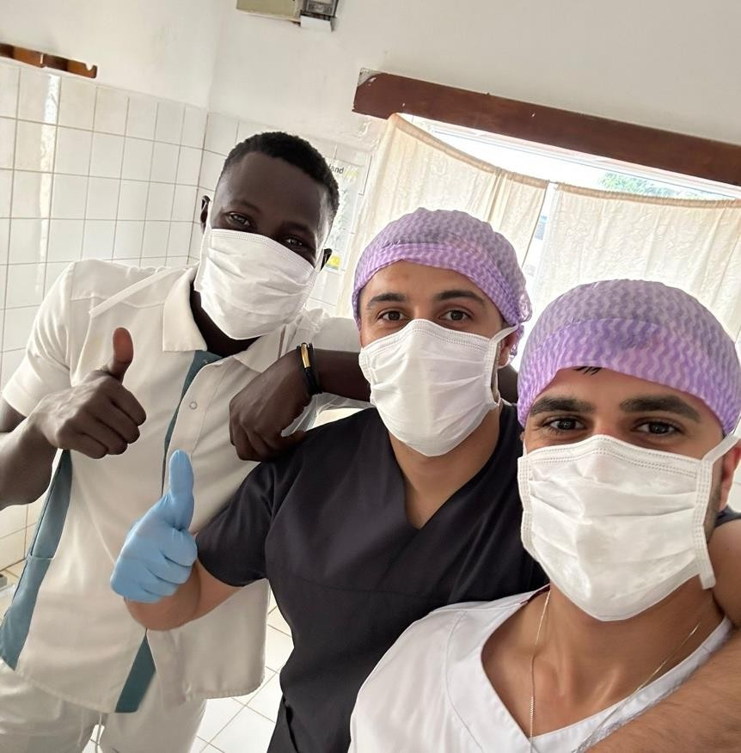
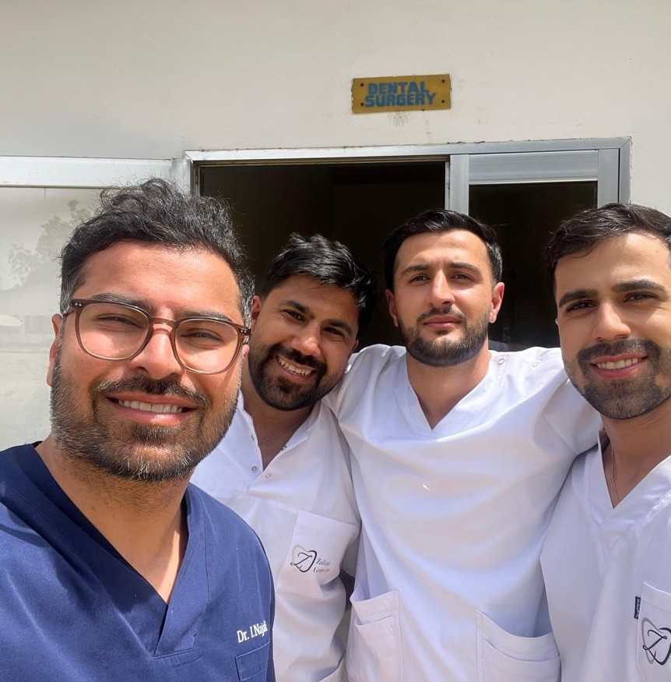

There is always time for a selfie


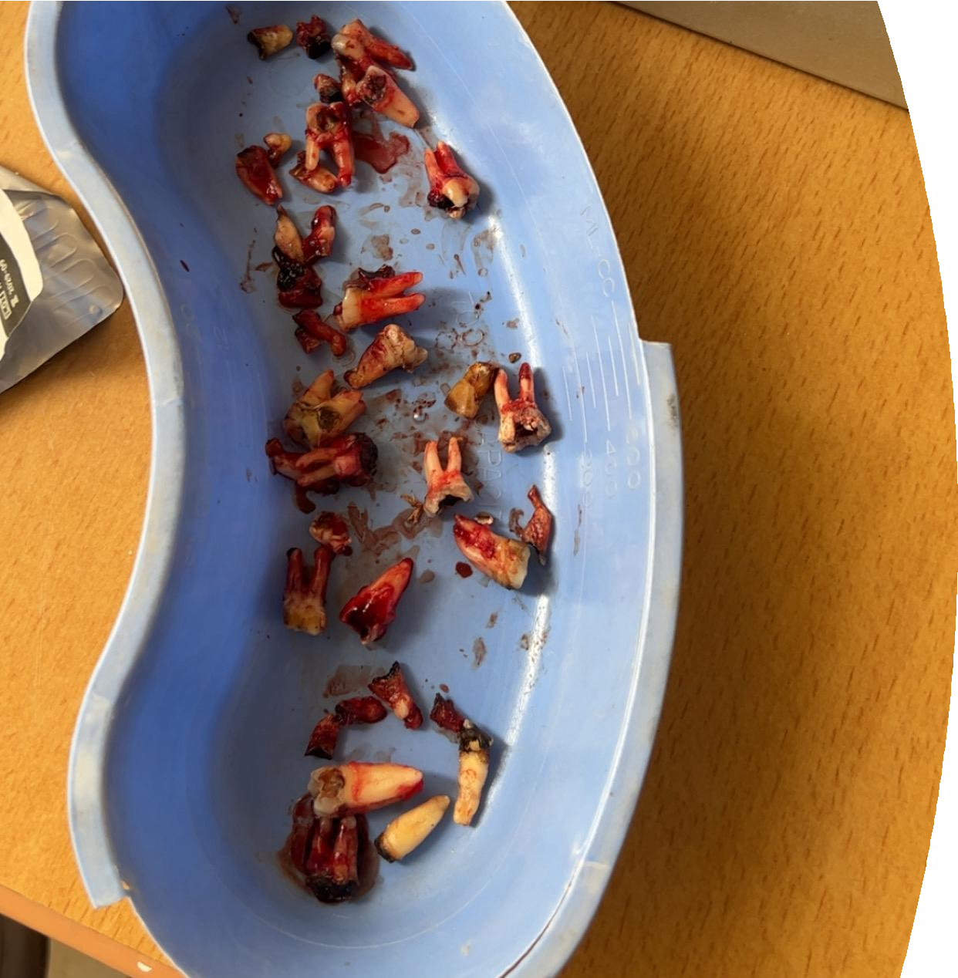
Overall

- 3 days work
- Working time 09.00-15.00
- 75 patients in total
- 41 woman – 22 men – 12 children
- Mostly heavily fractured teeth
- Root ends and wisdom teeth 100% humanitarian work

Challenges we faced

We noticed that the oral anatomy in the region presented unique challenges.
The mandibles were robust, and the tooth roots were firmly anchored in the bone, making extractions more demanding. Most procedures required extra time, care, and patience due to the strength and density of the supporting structures.

Many teeth were severely decayed, with crowns so damaged that fractures were common.

Overall oral health was poor, with most patients presenting advanced dental issues



A key reason for this condition is the lack of oral health education—there are few, if any, professionals to guide the community in basic dental care.

The local kindergarten - part of the jahaly health center - has 250 pupils separated into 6 classes. they are being taught english, maths, gardening, cooking. We find it very important to also make an impact on the future, so we are discussing with the headmaster about possible future projects related to the kindergarten

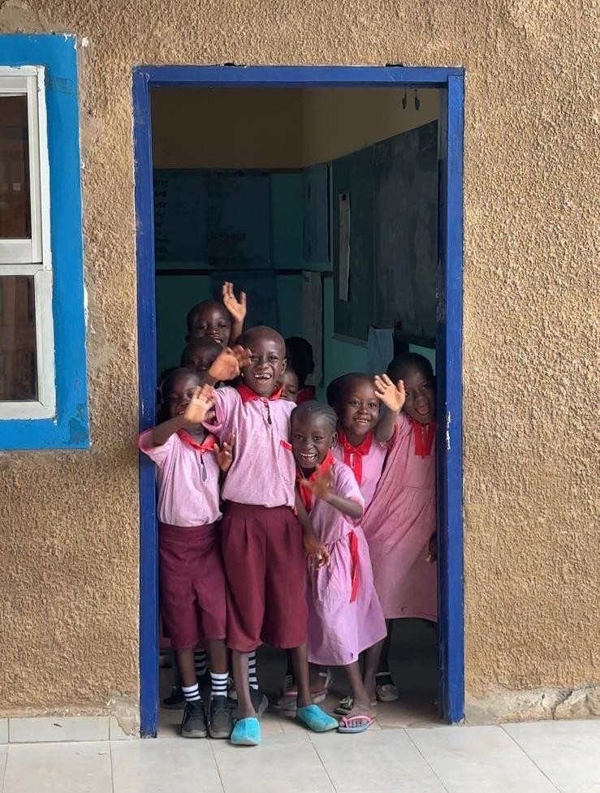
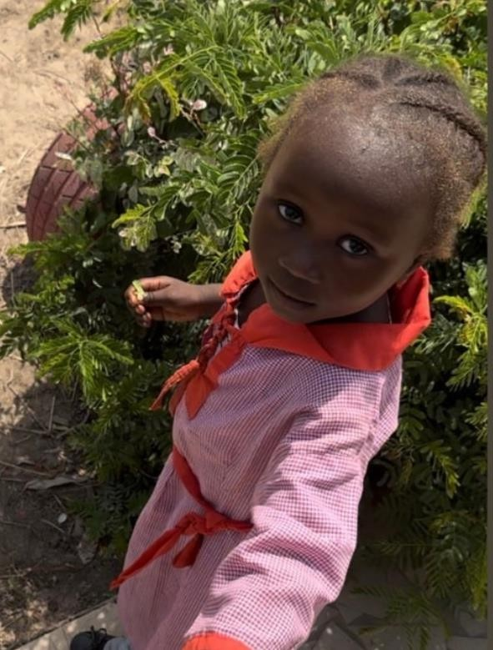
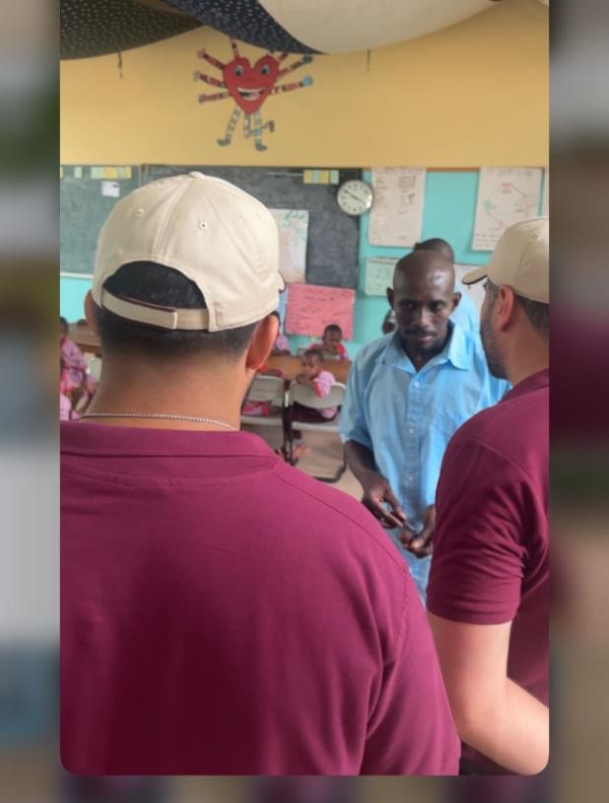
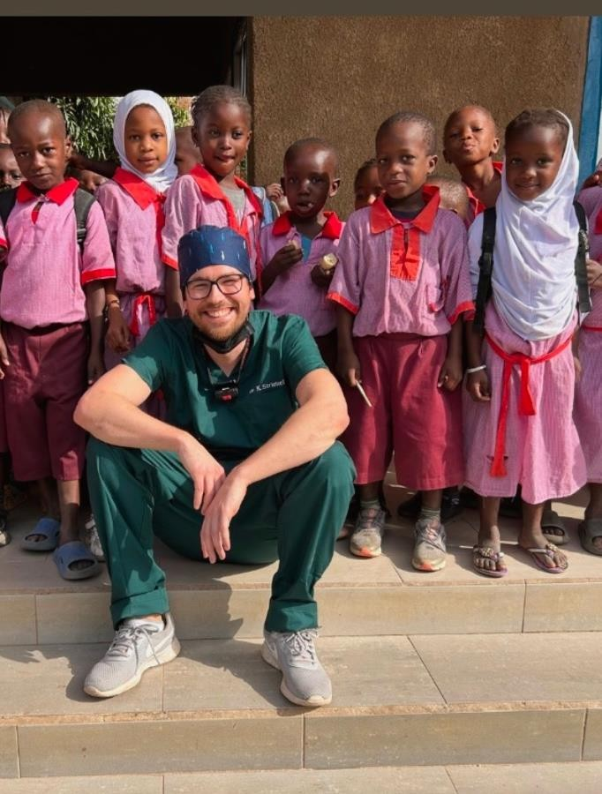

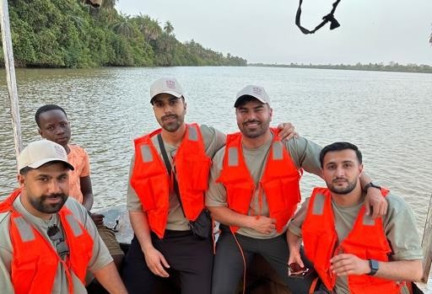
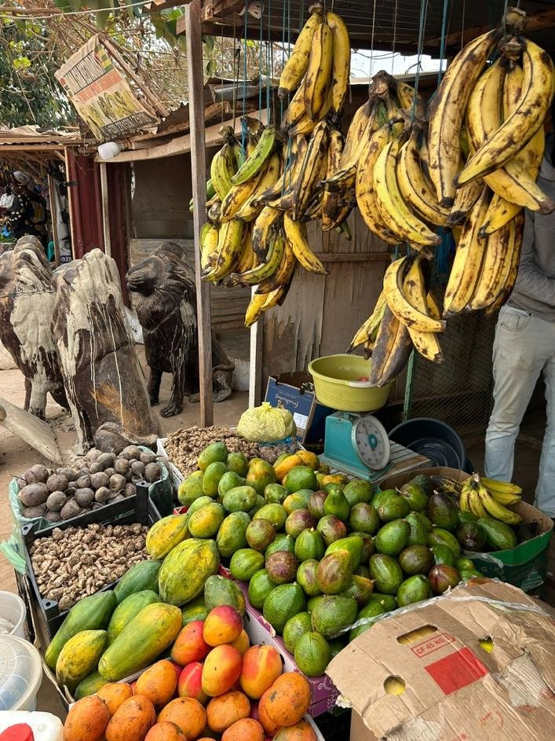
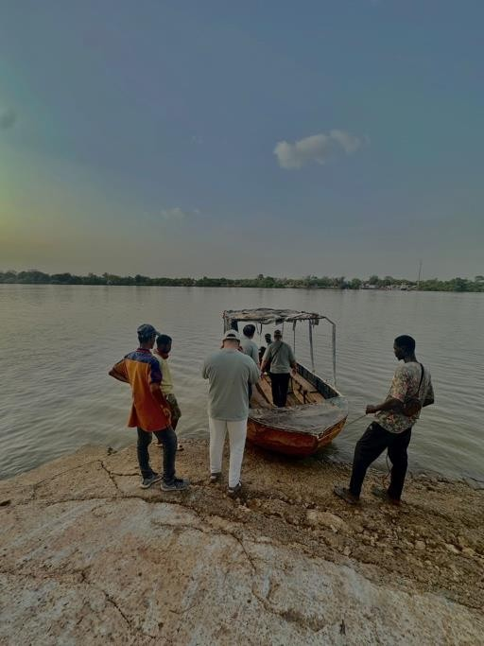
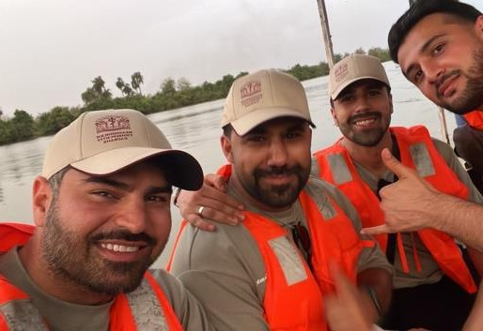
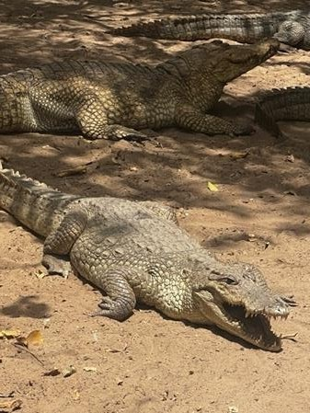

Some time for fun and activities: boat tour to look for crocodiles and hippos

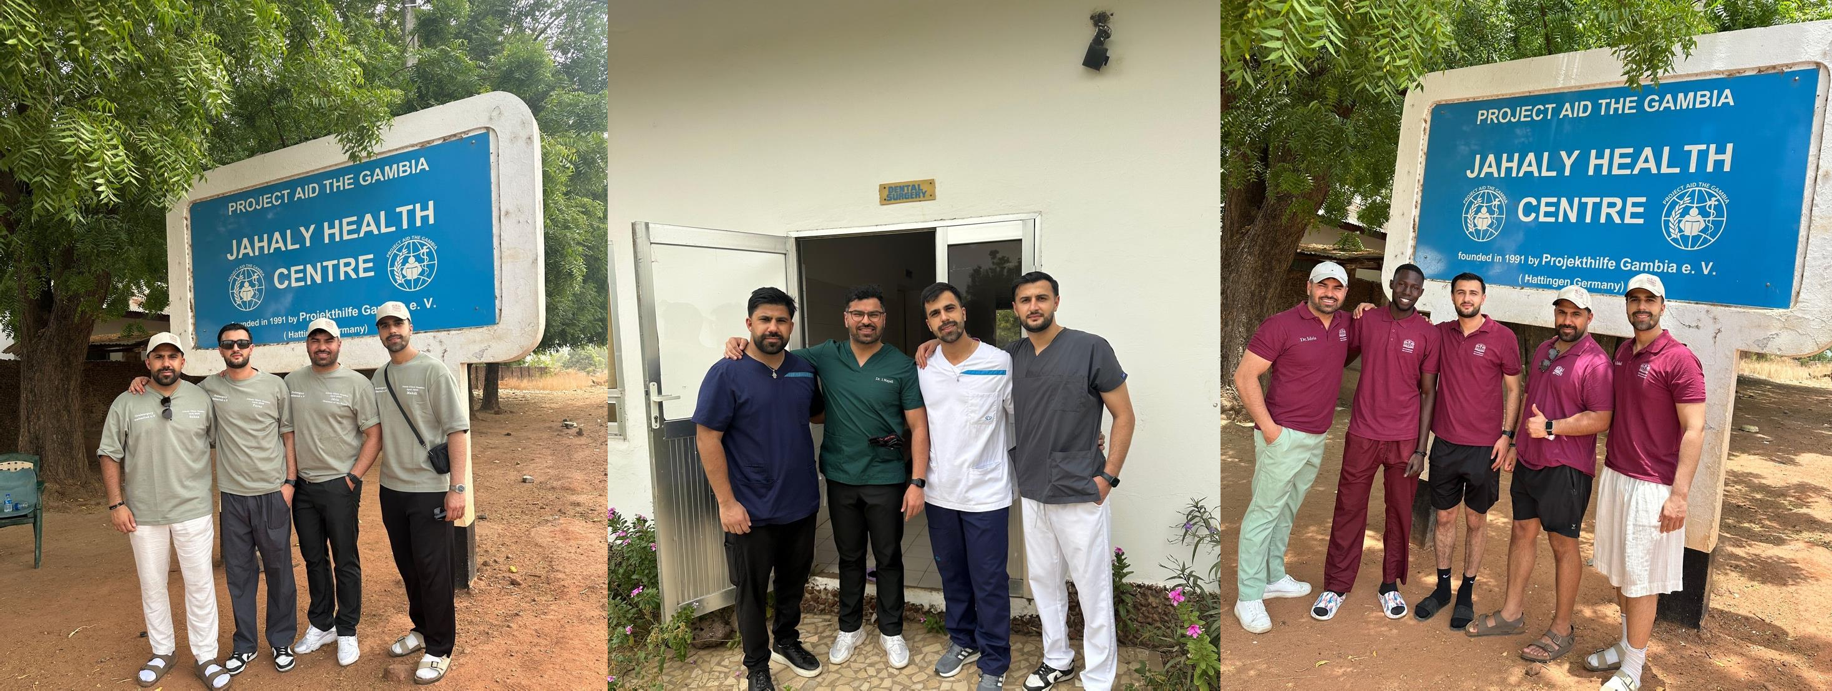

It was an honor to take part in humanitarian work and be dedicated to helping others. “The humanitarian work deeply moved us – it was something special to be able to support people directly. Since starting dental school, it is a motivation to help and support through our profession.

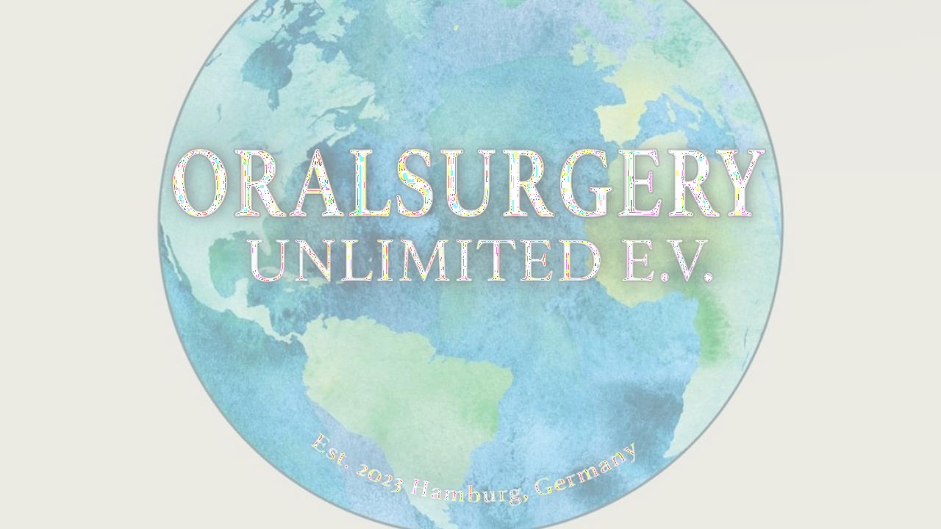

Future plans
Oral Surgery Unlimited is in talks with the ministry of health in gambia to prepare a 3 months curriculum and teach local health workers to be able to do treatments themselves. but also to increase the influence in other countries. we are already in talks in kambodscha, nepal and namibia

Collaboration with the university
As a proud graduates of the Faculty of Dental Medicine at Plovdiv Medical University (Class of 2020), we hold warm memories of the university’s enduring support for humanitarian values. It would be a meaningful accomplishment to initiate this program in cooperation with our alma mater. We are having a presentation of the charity organization on the 02.06 where the chairmen of Oral Surgery Unlimited will be discussing with the professors about possible cooperation's like : yearly trips for students to gain experience, assistant professors for supervision and professors for joining and teaching locals in the curriculum but also funding materials needed like gloves, masks, instruments.
The influence of university will get global

